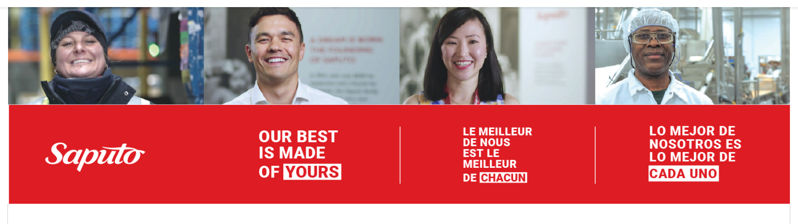

[**https://saputo.wd5.myworkdayjobs.com/Saputo_External_Careers/job/Dallas-TX/Regional-Aseptic-Manager_JR40840-1**](https://saputo.wd5.myworkdayjobs.com/Saputo_External_Careers/job/Dallas-TX/Regional-Aseptic-Manager_JR40840-1)

**Regional Aseptic Manager – Remote**

At Saputo, our best comes from our people. We’re a talented and caring team with a longstanding history of excellence. Since our first days delivering cheese on a bicycle, we’ve grown into a leading global dairy processor by staying true to the culture that defines us. Each of our employees is committed to uphold our tradition of care, quality, and passion through food, and together, we foster an environment where we can all make contributions that matter–from our manufacturing plants to our office locations and everywhere in-between.

**How you will make contributions that matter with your experience in *aseptic processing and filling of low-acid foods*...**

* Provide aseptic oversight, and guidance.
* Identify events and practices that impact aseptic food safety and quality; oversee their resolution to assure event is contained and appropriate steps are taken to mitigate risk to consumer, product, and the environment.
* Oversee investigations associated with deviations from scheduled processes and the implementation of corrective and preventive actions.
* Ensure all deviation reports and product dispositions are compliant with Process Authority recommendations.
* Conduct gap and risk assessments of aseptic processes, process interventions, practices, procedures and techniques against standards, policies, and industry best practices to ensure they are aligned with global Saputo Quality Standards and pertinent regulatory requirements,
* Provide mentoring, training and coaching of team members on aseptic practices, techniques, and Saputo Policies.
* Aid in equipment aseptic challenges, validations, re-qualification and commissioning.
* Maintain aseptic pre-requisite programs including CIP and COP in cooperation with Saputo’s corporate sanitation team and third-party providers.
* Support regulatory agency (state and federal) inspections; internal and customer audits. ​
* Work in close cooperation cross-functionally within the corporate QA, Operations, R&D and Sales departments to:
  + Develop, implement, and maintain quality systems in support of aseptic manufacturing and required documentation.
  + Aid with the assessment and implementation of new testing methods.
  + Work with employees across multiple departments and sites to assess areas for continuous improvement in relation to aseptic process/techniques and employee compliance to food safety programs and requirements.  Develop and execute mitigation plans.
  + Oversee general microbial testing/qualification activities (Raw material, In-process, Product and Shelf-Life product testing and critical utilities monitoring).
  + Compile and/or assess monthly and quarterly tracking/trending reports on relevant aseptic KPIs.
  + Attend and present quality metrics at the Site Quality Review Team Meetings.
  + Author and Revise Standard Operation Procedures.
  + Support On-Time and In-Full service for our customers.
* Role will require after hour and weekend support from time to time.

**You are best suited for the role if you have…**

* BS in Chemical Engineering / Process Engineering / Food Technology or equivalent; advanced degree preferred.
* Minimum of 4 years related experience preferred in an aseptic production environment with thorough understanding of aseptic principles, plant production systems, GMP, HACCP, sanitation, food safety, quality systems.
* Minimum level of prior or present responsibility as QA Supervisor or QA manager with multiple direct reports in aseptic food manufacturing.
* Prefer dairy experience.
* Prefer multiple plant responsibility/oversight.

**We support and care for our employees by providing them with…**

* Development opportunities that enhance their career fulfillment.
* Meaningful compensation & benefits that help them care for their families.
* Opportunities to contribute to your community and enhance the lives of others through Saputo products.

<https://saputo.wd5.myworkdayjobs.com/Saputo_External_Careers/job/Dallas-TX/Regional-Aseptic-Manager_JR40840-1>